Words and Whistles: Stockdog Commands
Voice  Commands | Whistle Commands | Explanation of Commands
Lie Down | One long blast | Stops dog
Come Here | Whee-Whee-Wheet | Brings dog to handler
Walk Up | Two short whistles | Moves dog straight toward the livestock
Come By | Wheet-Wheeeo | Moves dog around the livestock clockwise
Way to Me | Whee-Who | Moves dog around the livestock counter-clockwise
Get Out | Wheet-Wheeo-Wheet-Wheet | Moves dog away from the livestock
Look Back | Who-Hee-Who | Turns dog around to go gather more livestock
Take Time | Hee-Hee-Hee-Hee | Slows dog to a steady pace
That’ll Do | Whee-Whee-Wheet  (Same whistle as come here command) | Orders dog to quit working
General Description of Course, Rules and Scores
The following description is intended as a general guideline only. The number of sheep used in the semi-final and final runs, the number of shed sheep or the course pattern may change. The handler must adjust to these changes as well as other variables such as the weather, sheep temperament and condition, terrain, altitude and time of day.  All dogs are required to perform the same work on the same course under the same scoring rules. The initial work, the outfield work, tests the dog’s natural ability to locate, establish control over and move the sheep calmly and quietly. The second phase of work, the infield work, tests the dog’s training and the team’s effectiveness. Elimination, semi-final and final runs have allocated time limits determined by the judge. | 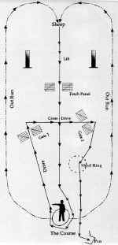  Qualifying Course
Outfield Work: Consists of the Outrun, Lift and Fetch
The Outrun: 20 points. Before the run, the handler and the dog take their positions at the handler’s post. With the sheep in place and upon the signal of the Course Director, the run begins. The dog is directed to go on either a left or right pear-shaped outrun. Points are deducted if the dog crosses over between the handler and the sheep before circling in behind the sheep in preparation for the lift. Points are deducted for voice or whistle commands required to direct the dog. A higher point deduction occurs if the dog stops or has to be stopped for redirection.
The Lift: 10 points. The sheep should not be startled or frightened by the dog’s approach. As the dog takes control, the sheep should start to move quietly and steadily toward the handler. A hesitant or rough lift, or many commands to prompt the dog are penalized.
The Fetch: 20 points. The fetch should be on a relatively direct line from the point of contact and lift, through the fetch panels, to the handler. Points are deducted for a missed panel, excessive swerving, zigzagging, wide or hard flanking, a stop-and-start pace or other deviations from a fairly direct line. Turning too widely around the post or veering towards the center of the field after the turn also penalizes the work. The fetch ends when the sheep have turned around the handler at the post.
Infield Work: Consists of the Drive, Shed, Pen
The Drive: 30 points. From the handler’s post, the dog is required to drive the sheep away on a diagonal to the left or right according to the judge’s predetermined preference, toward and through one set of panels and then horizontally through a second set of panels (gates #1 and #2 on the Qualifying Course Description). If either gate is missed on the first attempt, no second try is allowed. Points are deducted if the dog fails to negotiate the sheep through the gates or the work is performed at an uneven pace, in a zigzag line or with unclean turns. The nature of the work and the conditions and handling of the sheep may also determine point deductions. The drive ends when the sheep enter the shedding ring at which point the handler enters the ring to assist the dog.
The Shed: 10 points. Shedding includes the dog’s work in bringing the sheep from the drive into the shed ring. Separation of the prescribed number of sheep from the flock must be done inside the ring. After the shed is accomplished, the sheep may leave the ring but must be reassembled there before penning. Points are lost for failed attempts, if the handler intervenes too much, if opportunities to shed are missed, or if the dog does not come in when commanded or does not demonstrate full control of the shed sheep.
The Pen: 10 points. When the shed is complete, the handler may open the pen gate. Once the gate is open, the handler may not drop the rope and is confined to movements along its six-foot length. The dog and handler work the sheep into the pen in a counter-clockwise direction. Contestants may use crooks or canes to only block the sheep. At no time may these implements be used to abuse the sheep. Touching the sheep with the cane, crook or hand disqualifies the handler. Points are lost for breakaways, milling around the mouth of the pen or circling the pen in the wrong direction.
The Single Shed: 10 points. This work is generally added to only the semi-final run. The handler proceeds to the shed ring, leaving the dog to bring the flock from the pen to the ring. The dog then sheds one sheep from within the ring and holds it away from the rest of the flock. Point deductions are based on general shedding rules.
The Double Lift Final: total 170 points
broken out as follows:
1st Outrun, 20
1st Lift,10
1st Fetch, 20
2nd Outrun, 20
2nd Lift, 10
2nd Fetch, 20
A total of 100 for both Outruns, Lifts & Fetches
Drive, 40
Shed, 20
Pen, 10
In the final run, the double lift replaces the lift, no single shed is performed and point allocations are adjusted. Two flocks of 10 sheep each must be gathered from different parts of the field and united en route to the handler. The infield work then ensues with the 20-sheep flock. During the shed the five collared sheep are separated and kept in the ring while the unmarked ones are run out of the ring. If a collared sheep rejoins the sheep outside of the ring, all must be re-gathered, and the shed begins again. Points are deducted based on the previous shed rules. The collared sheep are then penned, again with points deducted according to general penning rules.
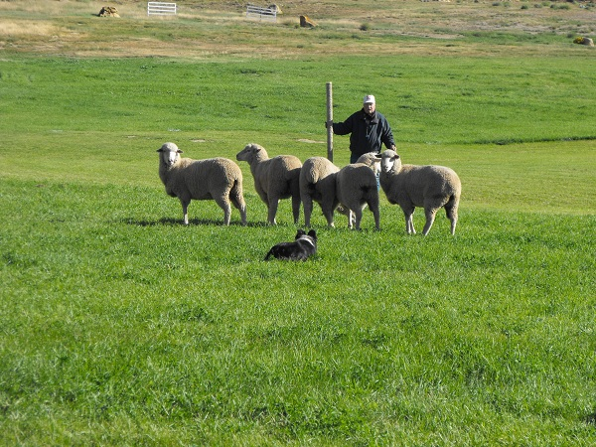
Quick Guide to Required Work Phases
Outrun . . . The dog may go right or left in a pear-shaped arc to a position behind the flock. The dog must not cross over the field between the sheep and the handler.
Lift . . . In a quiet, gentle manner, the dog moves the sheep off the drop point. After the first few steps, the lift turns in to the fetch.
Fetch . . . The dog brings the sheep, in as direct a line as possible, through the fetch panels to the handler. The sheep should move as one group at a steady pace.
Drive . . . The dog pushes or drives away from the handler through the designated panels, in as direct a line as possible.
Shed . . . After collecting the sheep in the shed ring, the dog cuts off and holds apart the designated number of sheep.
Pen . . . The handler opens the gate, keeping a hold on the rope, and directs the dog to put the sheep in the pen. The handler does not have to stand still but may not touch the sheep.
Single Shed . . . The handler leaves the pen and enters the ring while the dog drives the sheep into the ring. The dog sheds one sheep from within the ring and holds it apart from the flock.
Double Lift . . . The dog gathers two flocks of sheep from different parts of the course and unites them prior to the infield work.

